**ASSIGNMENT 7:** Module 12: Building Database Apps with PostgreSQL & Python

Create Database in PostgreSQL:

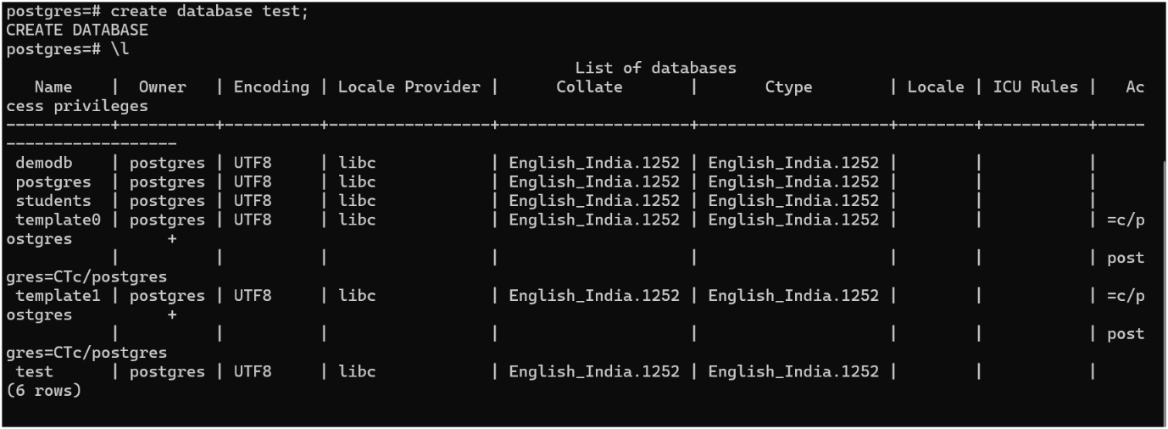

Create Table in Database:

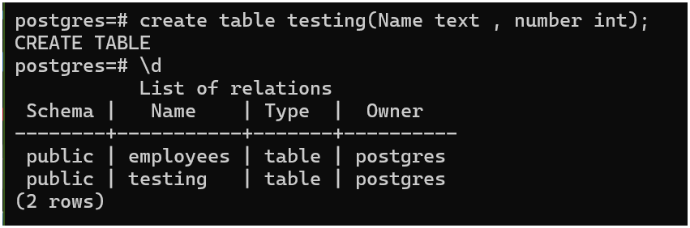

INSERTING DATA ;

DELETING THE DATA AND DELETING THE TABLE ;

CREATING TABLE THROUGH PYTHON IN PSQL:

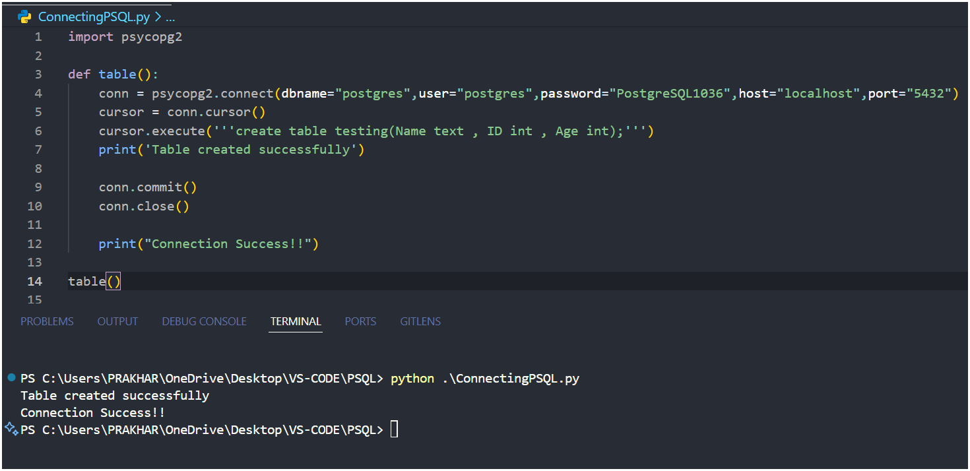

INSERTING VALUES:

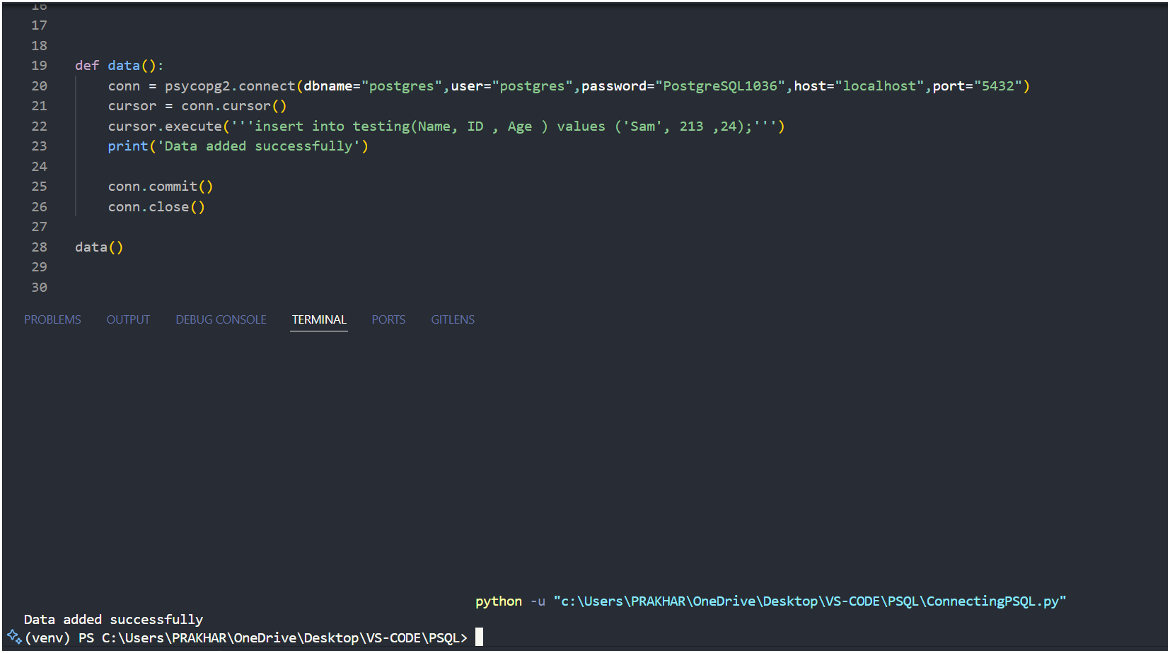

EXTRACTING VALUES:

ADDING VALUES :

